Name:

### Score: out of

# Manjimup SHS 2015

# Year 11 Mathematics Methods

# Test 3

# Quadratics, Functions, Transformations, Trigonometry

**30**

**Non Calculator Section (No calculator or notes, formula sheet provided)**

**Time: 30 minutes Marks: 30 marks**

1. [2,2,2 = 6 marks]

Use algebra to solve the following equations.

1. (4x – 5)(x + 3) = 0 b) x2 = 2x + 15 c) x3 – 4x2 = 0
2. [2 marks]

Find the exact values of

1. cos 210o b) tan 

3. [3 marks]

Consider the quadratic function f(x) = x2 – 8x – 9

Find the turning point of f(x) , by using the completing the square method.

4. [3,2 = 5 marks]

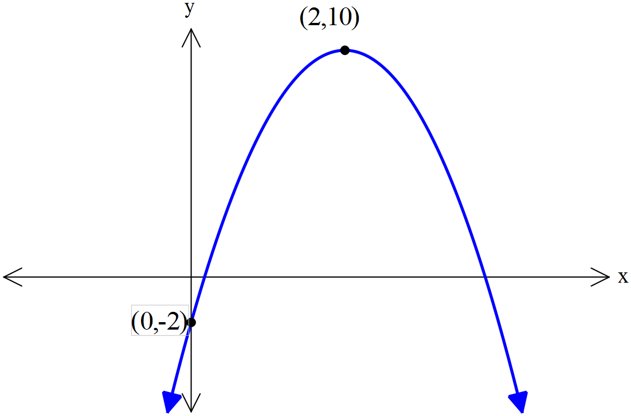

The rule for the graph shown is y = a(x – h)2 + k

1. Determine the values of a, h and k and

write the full rule below.

1. Use algebra to change your rule into standard form; y = ax2 + bx + c

5. [2 marks]

Consider the rule: y = 7 – 2 cos (.

1. Find the maximum value of the function y = 7 – 2 cos (.
2. Find the period of the function y = -4 tan(2πx)

6. [2 marks]

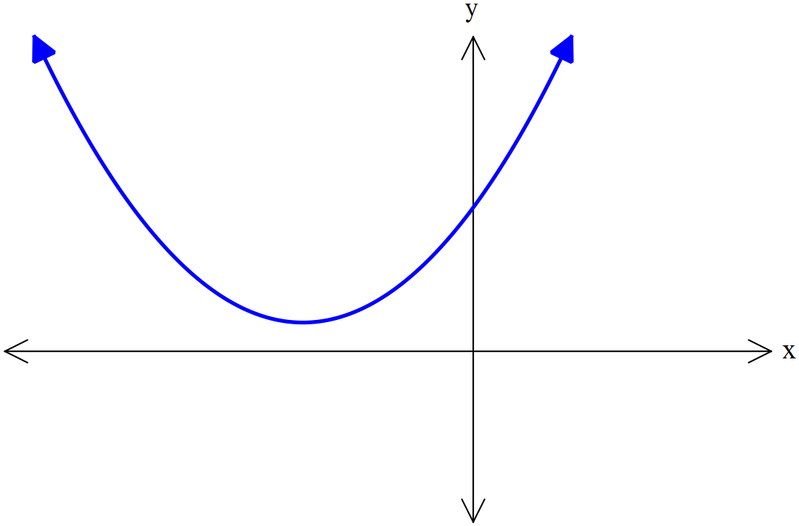

This following graph has no roots.

Select the correct rule from the list below.

Justify your answer using mathematics.

y = x2 + 4x + 3 y = x2 + 4x + 4 y = x2 + 4x + 5

7. [3 marks]

Sketch the cubic y = 2(x + 3)(x – 2)2 indicating all roots and y-intercepts.

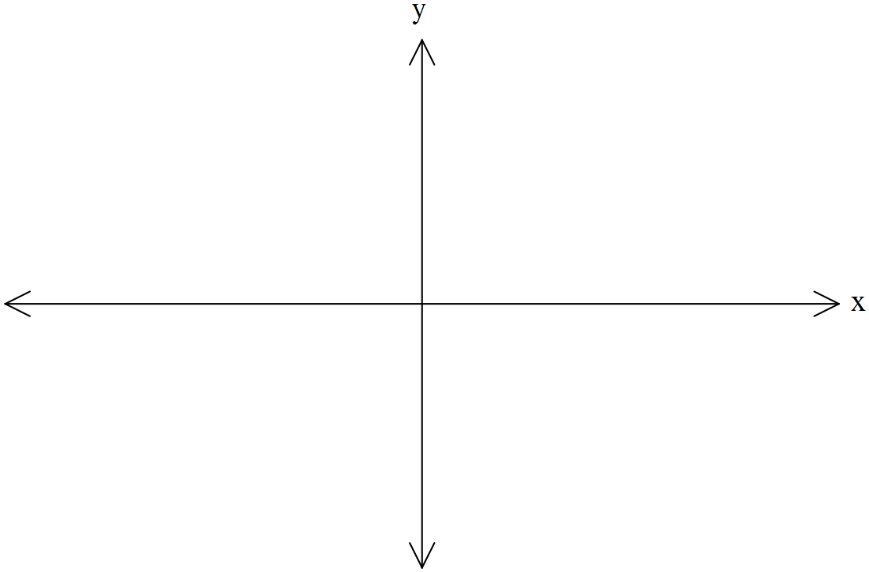

8. [3 marks]

The grid below shows a graph of y = cos(x) from 0 to 3π.

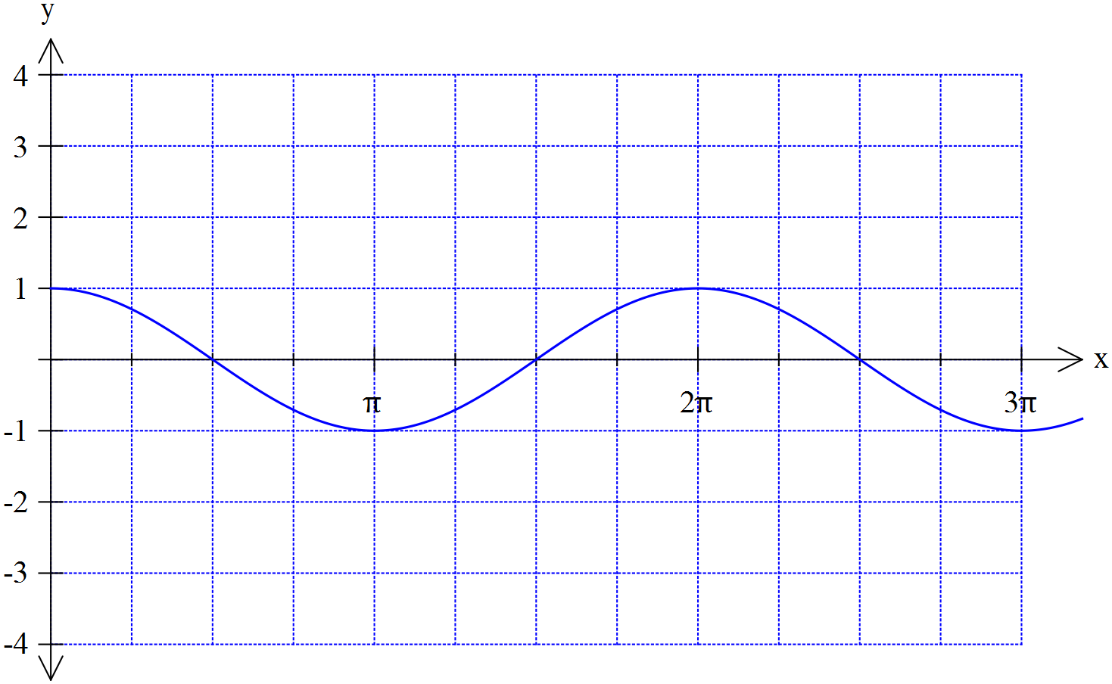

Plot the graph of y = -3 cos (2x) on the axes above

9. [4 marks]

Find all solutions to the equation cos (2x) = 0.5 for the domain 0 ≤ x ≤ 360o

# Manjimup SHS 2015

# Year 11 Mathematics Methods

# Test 3

# Quadratics, Functions, Transformations, Trigonometry

Name:

### Score: out of

**26**

**Calculator Section (Calculators and 1 page (A4) of notes permitted, formula sheet provided)**

**Time: 40 minutes Marks: 33 marks**

10. [4 marks]

Determine the rules for these functions.

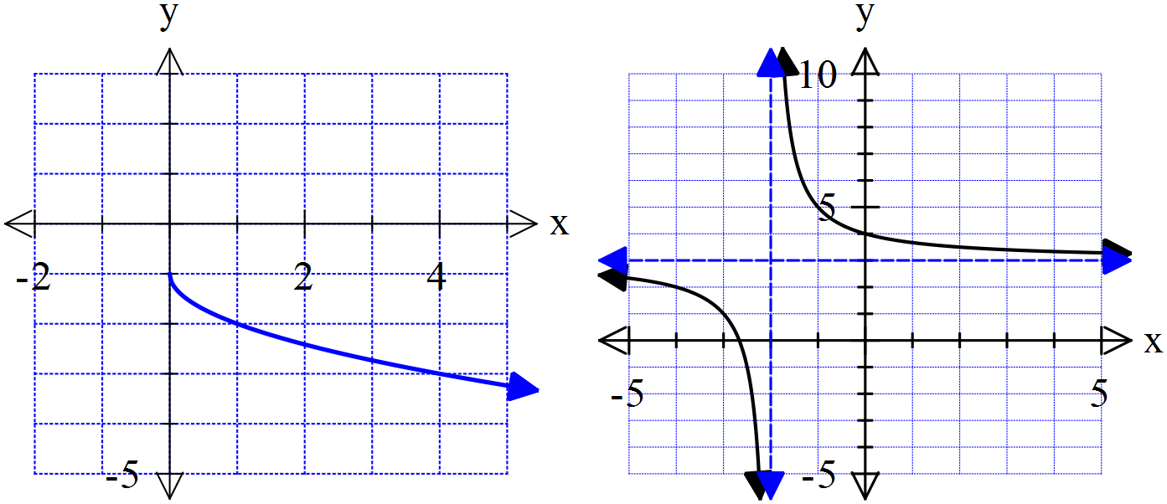

…………………………………

………………………………..

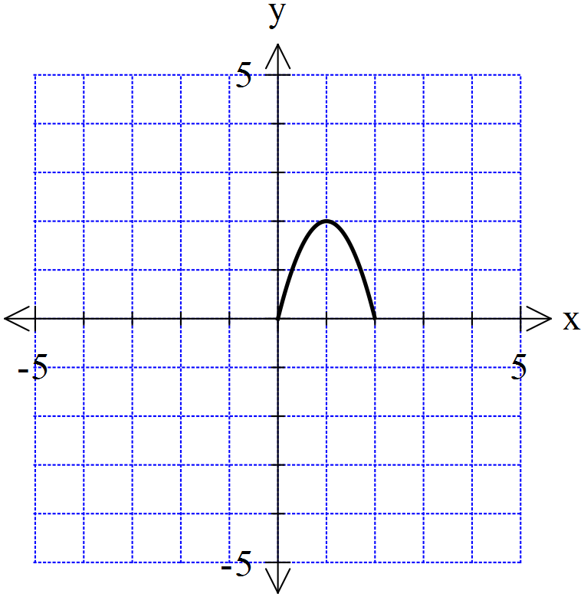

11. [2,3 = 4 marks]

Shown to the right is a graph of the function f(x).

Using your knowledge of transformations sketch

the following

1. y = 2 f(x + 4) b) y = - f(-2x)

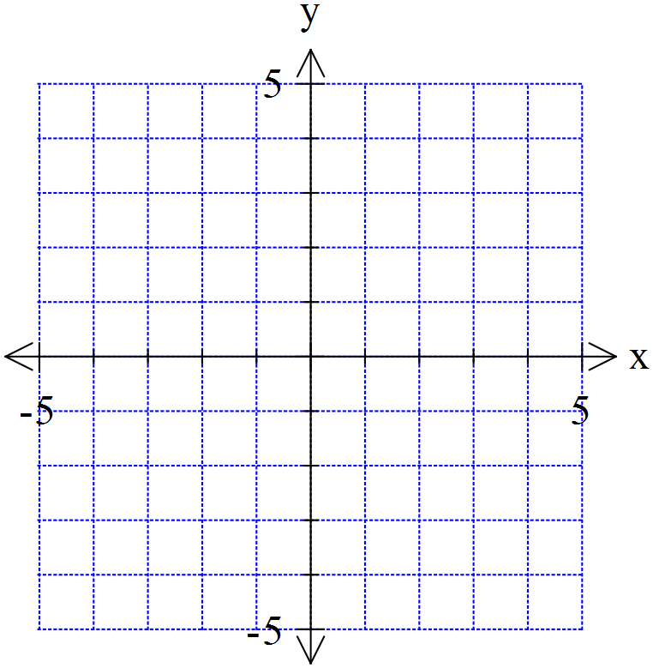



12. [2,3,2 = 7 marks]

a) State the rule for a circle with a radius of with a centre of (-2,1).

b) Write the rule in the form x2 + y2 + dx + ey = f

1. Determine the distance from the closest point on the circle to the origin at (0,0)

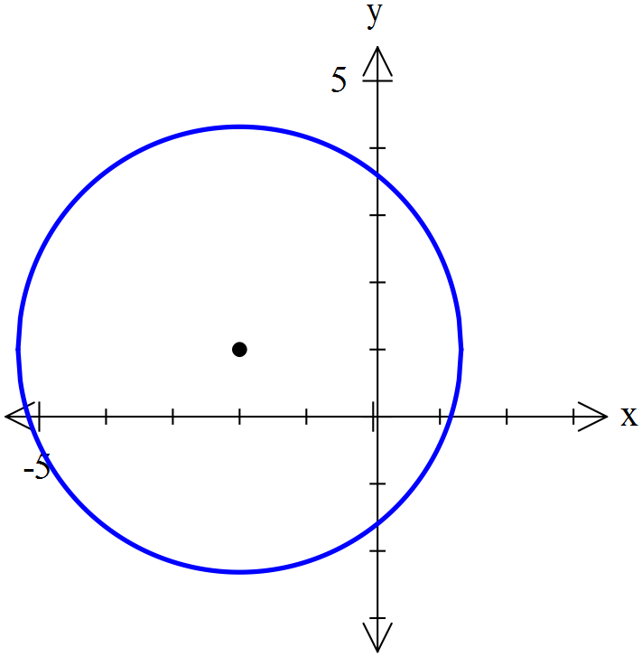

13. [1,4,1,2 = 8 marks]

The depth of water in a flask in a science experiment was measured for an eight hour period and followed the rule , where  was the number of hours since the experiment began and  the depth of water in centimetres.

1. What was the depth of water when the experiment began?

Graph  on your calculator. Use it to answer the following questions

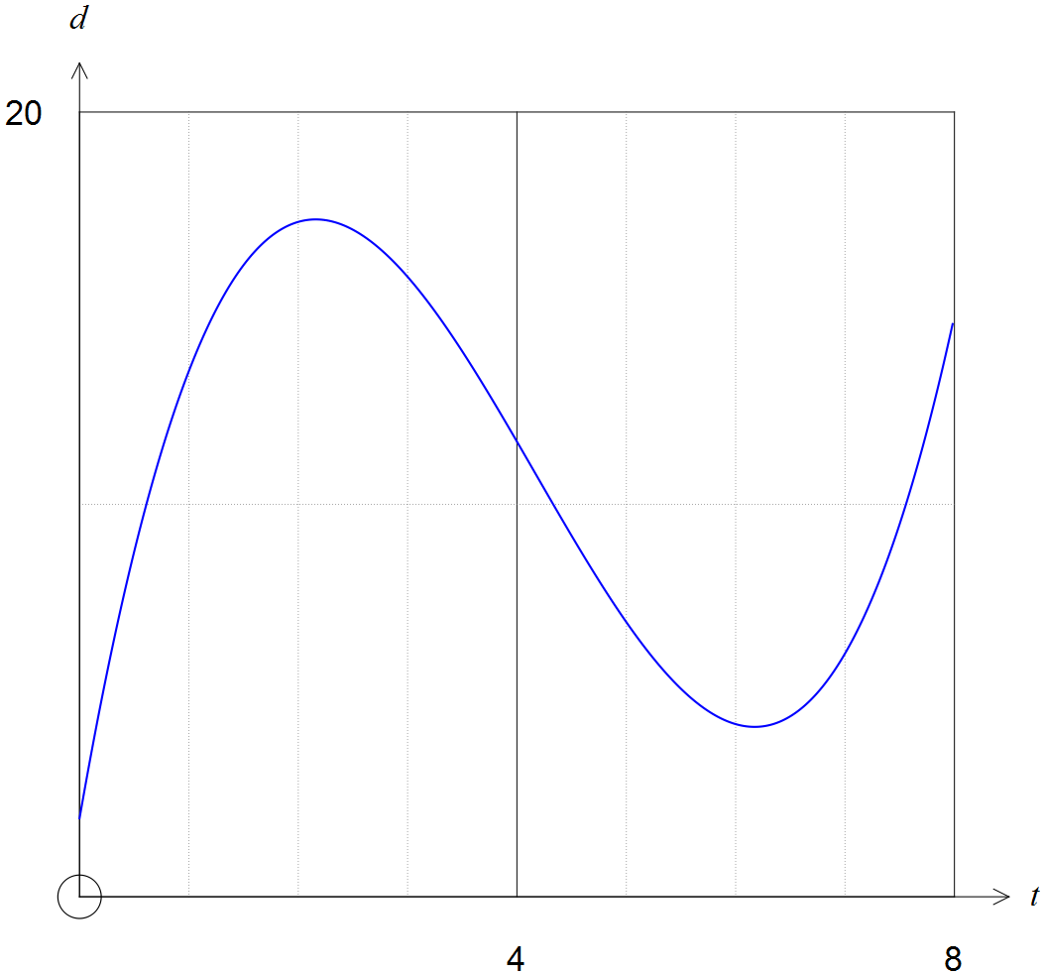

1. In total for how many hours and minutes was the depth 10cm or more during the eight hour period?
2. What was the minimum depth of water during the first eight hours?
3. At what time, correct to nearest minute, was the depth a maximum during the first eight hours?

14. [3 marks]

Use the *quadratic formula* to solve 0 = 10x2 – x – 2. Show all steps clearly.